Triple Rhyme

🔹 What is Triple Rhyme
# Source: Chatgpt (GPT-4-turbo) at [8/2/2025]
⚠️ Triple rhyme is a type of poetic rhyme, not a type of homograph. However, homographs may appear in triple rhymes if they have matching pronunciation and syllable stress.

✅ Definition of Triple Rhyme
# Source: Chatgpt (GPT-4-turbo) at [8/2/2025]
Triple rhyme occurs when the last three syllables of two words or phrases rhyme, with the first of the three syllables stressed and the next two unstressed.
It’s a form of multisyllabic feminine rhyme:
DA-da-da rhyme pattern.

🧠 Key Features
# Source: Chatgpt (GPT-4-turbo) at [8/2/2025]
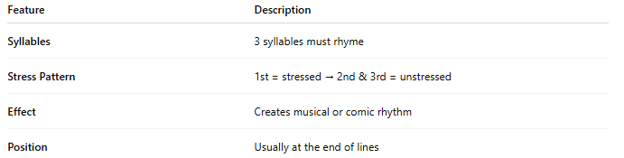
Feature | Description
Syllables | 3 syllables must rhyme
Stress Pattern | 1st = stressed → 2nd & 3rd = unstressed
Effect | Creates musical or comic rhythm
Position | Usually at the end of lines

📝 Examples of Triple Rhymes
# Source: Chatgpt (GPT-4-turbo) at [8/2/2025]
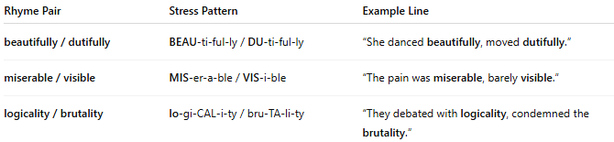
Rhyme Pair | Stress Pattern | Example Line
beautifully / dutifully | BEAU-ti-ful-ly / DU-ti-ful-ly | “She danced beautifully, moved dutifully.”
miserable / visible | MIS-er-a-ble / VIS-i-ble | “The pain was miserable, barely visible.”
logicality / brutality | lo-gi-CAL-i-ty / bru-TA-li-ty | “They debated with logicality, condemned the brutality.”

🧪 Examples with Homographs (when applicable)
# Source: Chatgpt (GPT-4-turbo) at [8/2/2025]
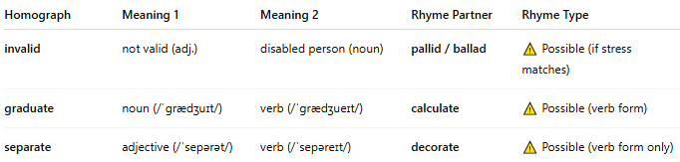
Homograph | Meaning 1 | Meaning 2 | Rhyme Partner | Rhyme Type
invalid | not valid (adj.) | disabled person (noun) | pallid / ballad | ⚠ Possible (if stress matches)
graduate | noun (/ˈɡrædʒuɪt/) | verb (/ˈɡrædʒueɪt/) | calculate | ⚠ Possible (verb form)
separate | adjective (/ˈsepərət/) | verb (/ˈsepəreɪt/) | decorate | ⚠ Possible (verb form only)
✔ Triple rhymes only work when the pronunciation of the homograph fits the DA-da-da rhythm exactly.

📊 Comparison: Rhyme by Syllable Count
# Source: Chatgpt (GPT-4-turbo) at [8/2/2025]
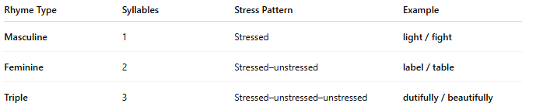
Rhyme Type | Syllables | Stress Pattern | Example
Masculine | 1 | Stressed | light / fight
Feminine | 2 | Stressed–unstressed | label / table
Triple | 3 | Stressed–unstressed–unstressed | dutifully / beautifully

✅ Summary
# Source: Chatgpt (GPT-4-turbo) at [8/2/2025]
- Triple rhyme involves rhyming three syllables, starting with a stressed one.
- Homographs can participate if their pronunciation fits the DA-da-da pattern.
- Common in humorous, musical, or light verse.

